RAID Configuration

Requirements

1) 4 Disks

2) Ubuntu 16.04 Server

3) mdadm

Login to the server & Check the Hard disks.

You can login to the server using ssh.

Screenshot from 2016-09-26 14-07-39

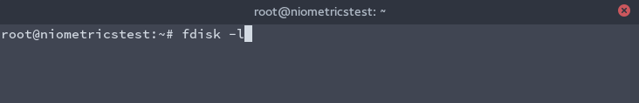

This will give all the Hard disk details on the system.

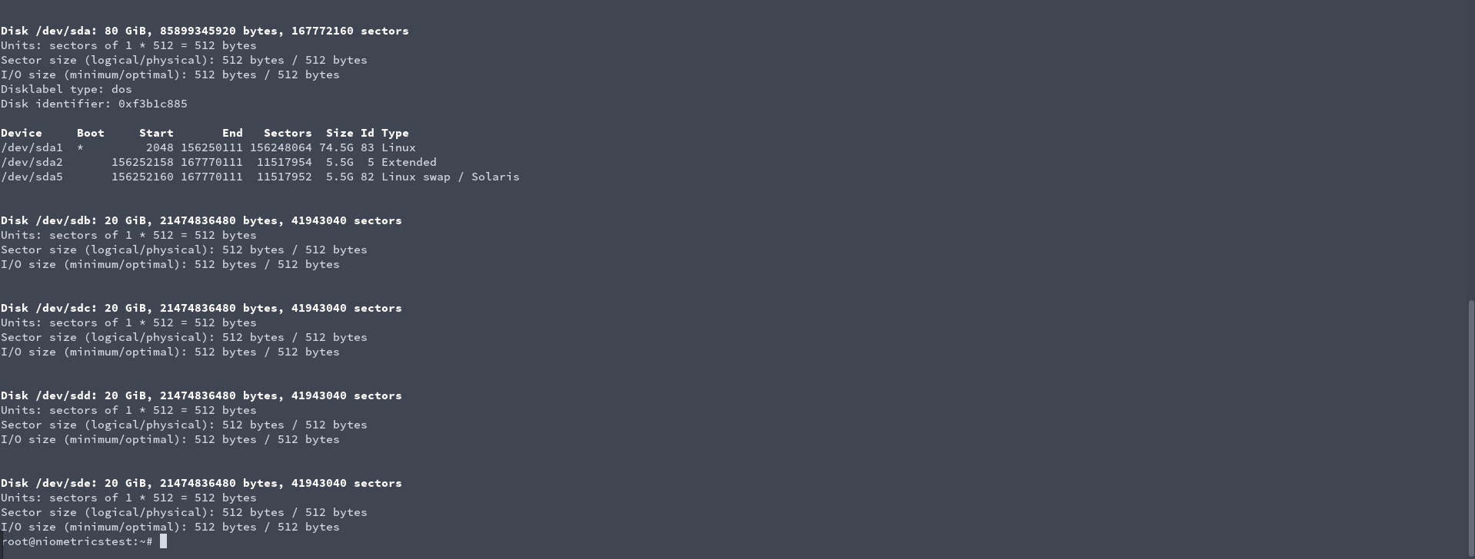

/dev/sdb, /dev/sdc, /dev/sdd, /dev/sde are the 4 Disks we are going to create the RAID. Each Disk contain 20 GB. Disks are new, dont have any partition yet. So, we need to create partition for each disk.

Use fdisk command to create the partition.

fdisk /dev/sdb

Create a new partition : n

Keep it default other options.

Tag the partition with Linux raid.

L will list all the types. Select fd.

And then display the partition using p.

Finally write the changes : w

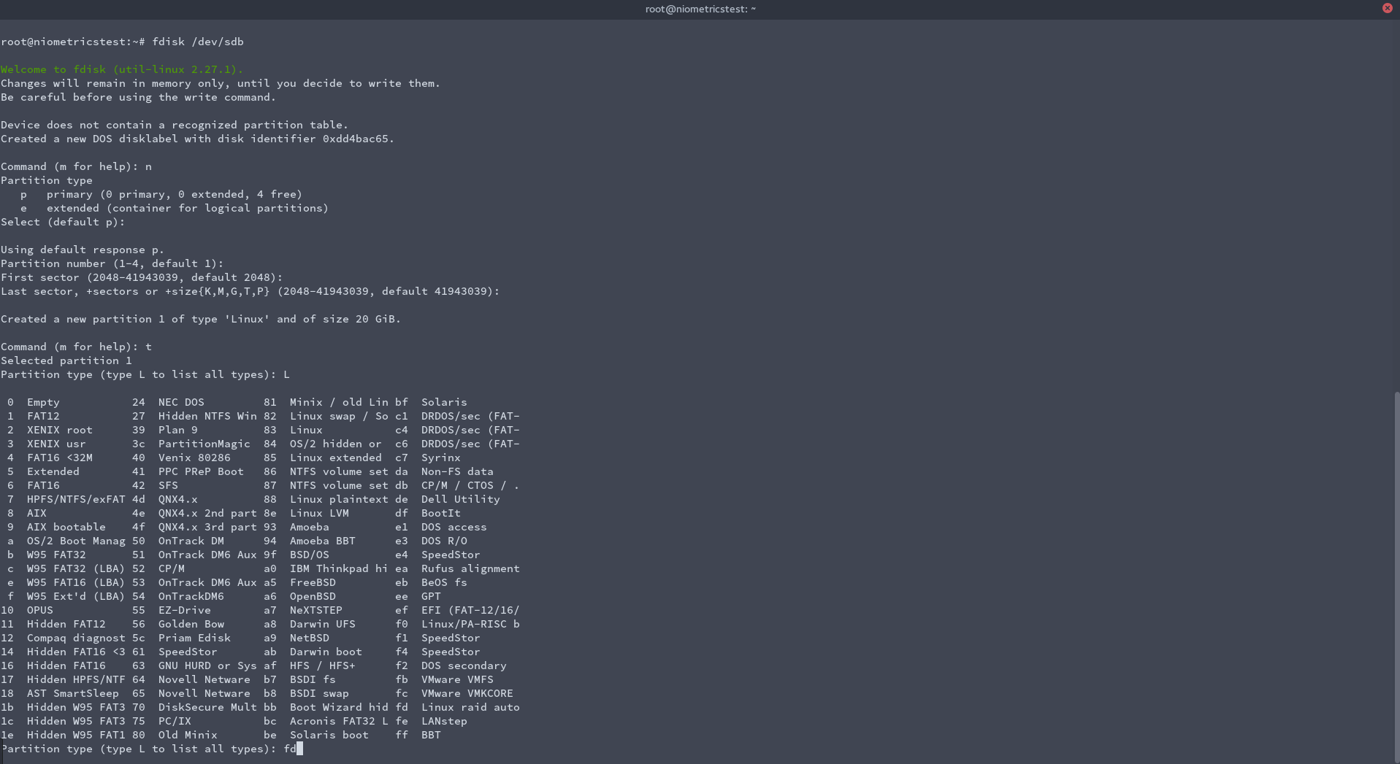

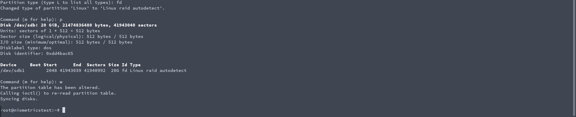

Do the above steps for other 3 Disks.

fdisk /dev/sdc

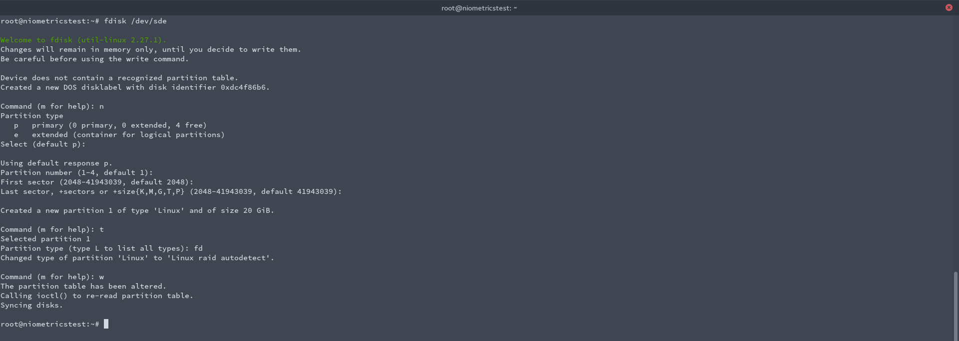

fdisk /dev/sdd

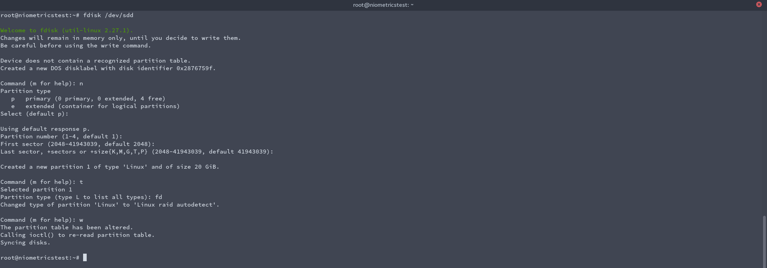

fdisk /dev/sde



After creating all the partitions, check the drives for any raid partition.

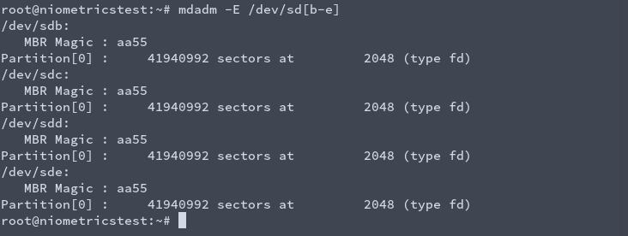

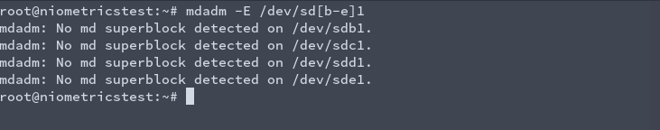

So, there is no superblock detected on newly created partitions. Now we can create RAID10 using the following command.



Here, we created new md0 device with raid level 10 using /dev/sdb1 , sdc1, sdd1 & sde1.

Verify the newly created raid.

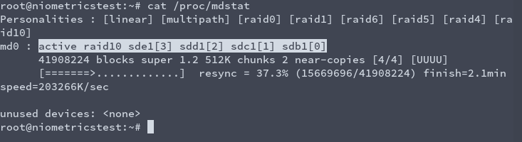

We can check the details of raid md0 using

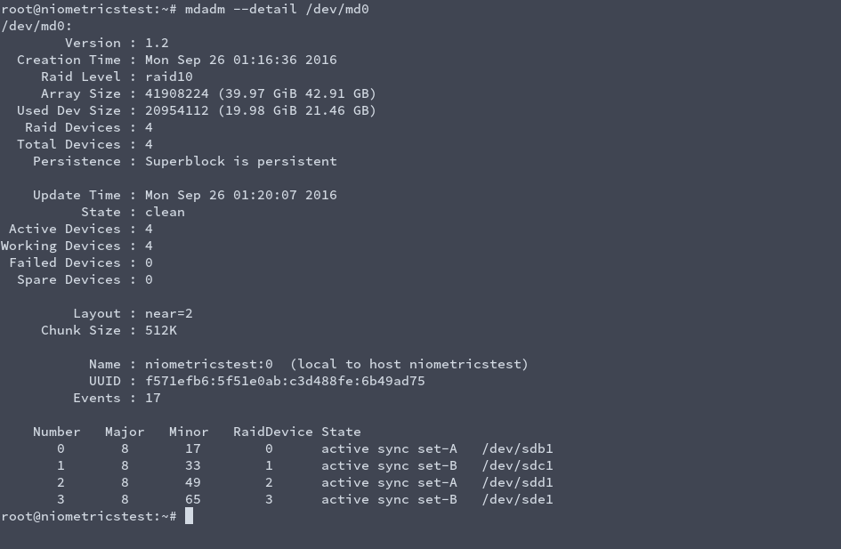

Now, the final step is to create a file system and mount md0.

Here, I am creating an xfs file system. Can use other file systems too depending on the need.

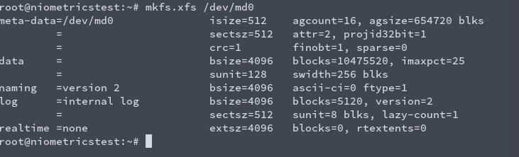

Create a folder and mount md0 to that folder.

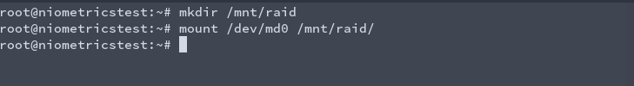

Check whether md0 is mounted or not.



Now, files can be created inside the folder.

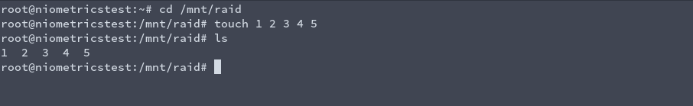

This type of mounting is temporary. When system restarts, we need to mount again. For making persistent, we need to add entry inside fstab.

Screenshot from 2016-09-26 11-04-21

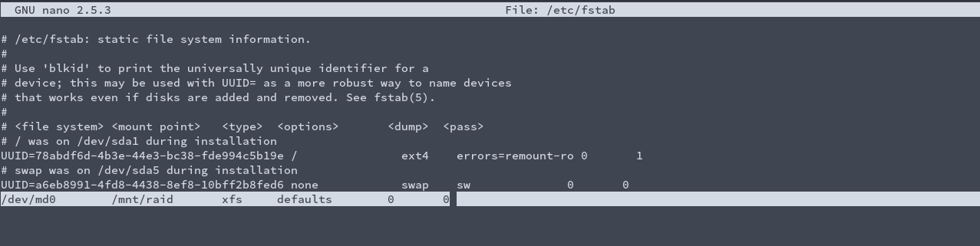

/dev/md0 is mounted on /mnt/raid using xfs file system.

Verify using mount command.

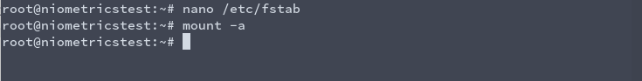

It does not gave any errors.

Another important note is to save configuration. We need to add entry to mdadm configuration files also.

It is located on /etc/mdadm/mdadm.conf

Append the output of following command to that configuration file.

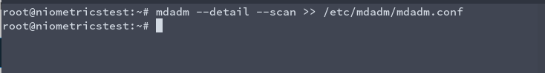

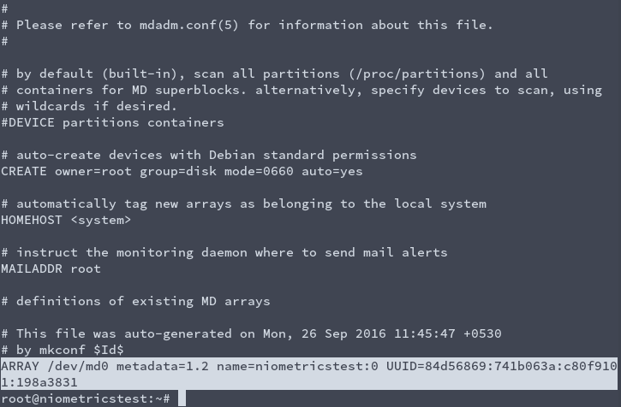

Now edit the entry. Remove name & metadata field. Now it may look similar to -

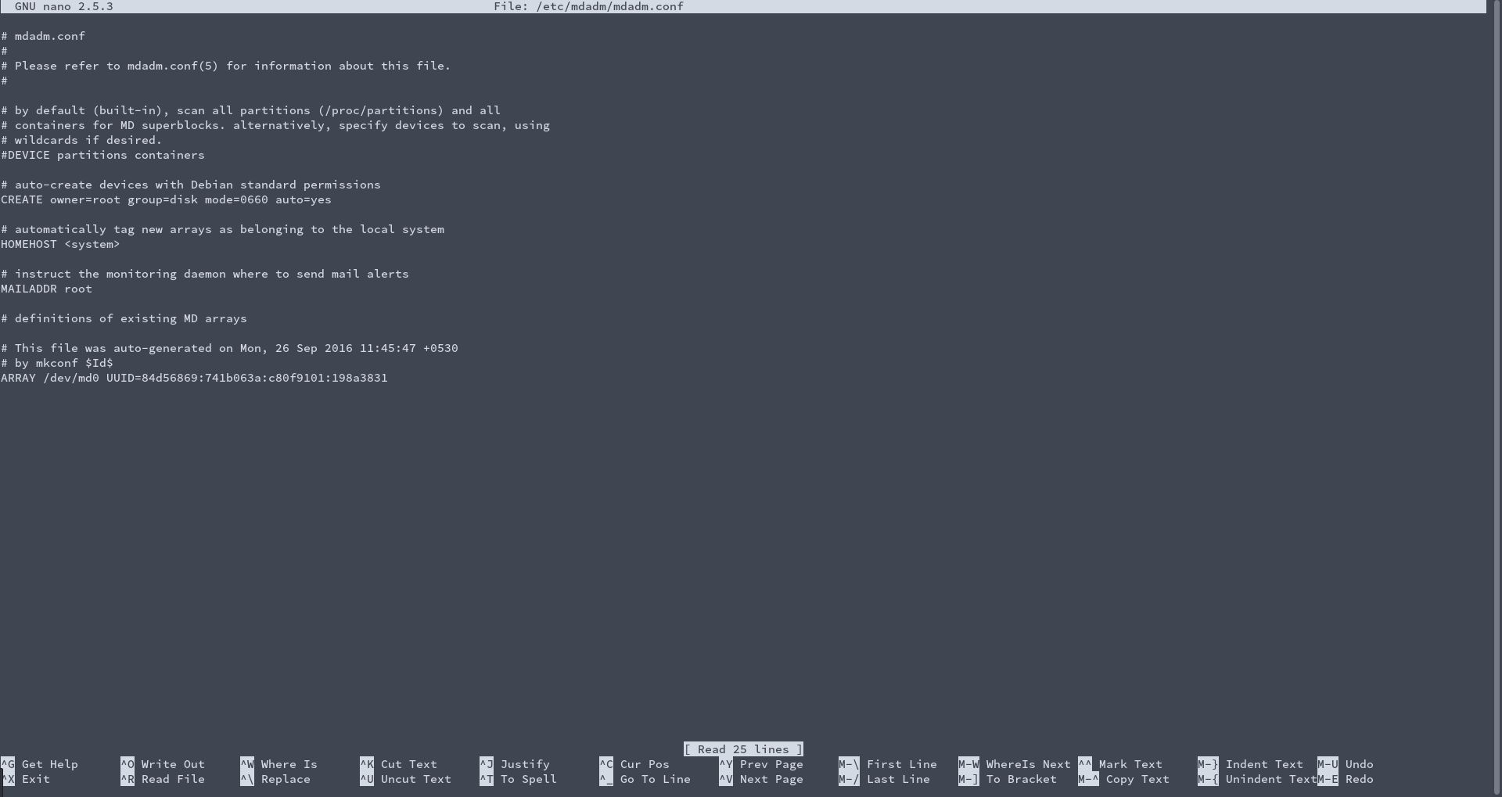

We finished setting RAID10.

Reboot the system and verify RAID is mounted.



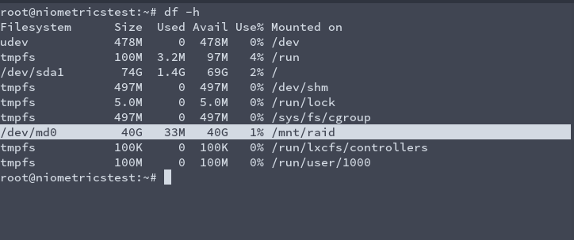

Replacing Faulty Hard disk.

For this example, lets make a disk faulty.

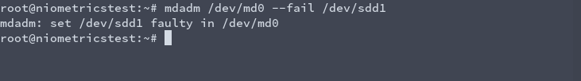

Check the raid now.

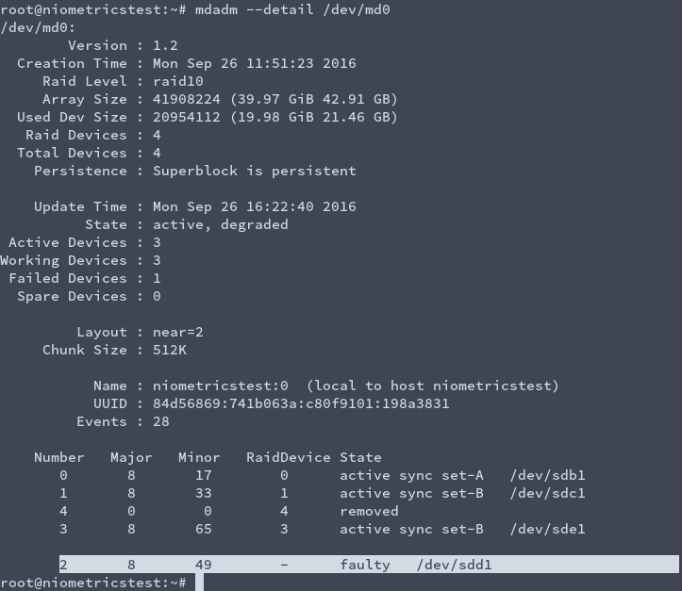

We found /dev/sdd1 is faulty. Now we need to remove this disk and add new disk.

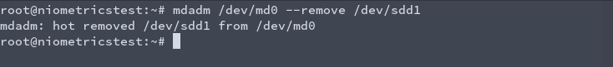

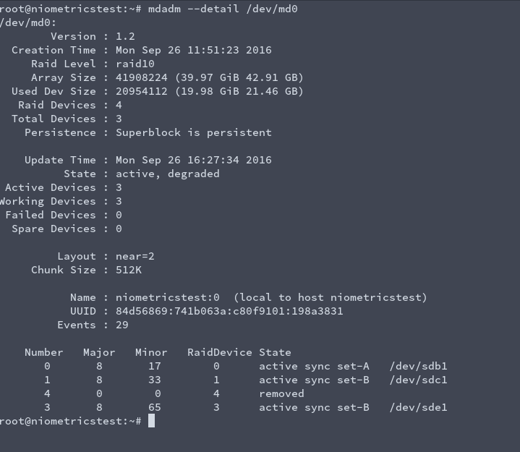

Now I added a new Hard Disk, sdf.

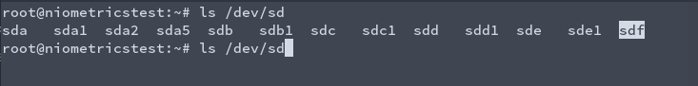

Create a partition and tag with raid as we did like earlier.

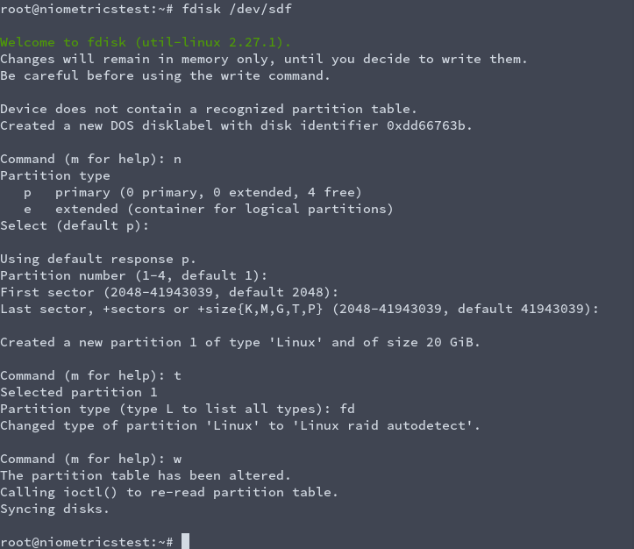

Add this disk to our raid md0 and verify it.

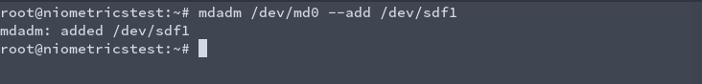

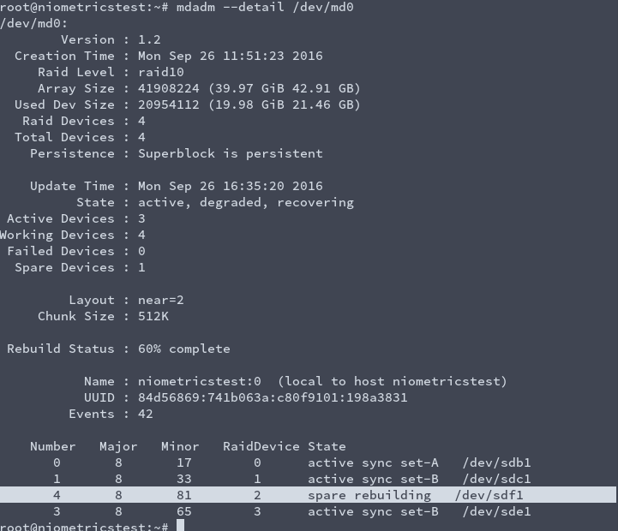

We can see /dev/sdf1 is added to raid instead of faulty disk /dev/sdd1. Its rebuilding the structure. After some time, status will change to active, sync.

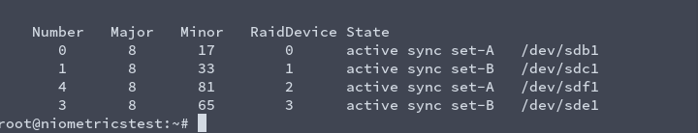

Web server

First we need to install necessary packages.

Installing Apache2

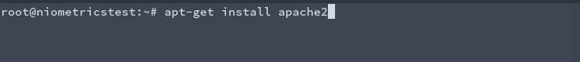

Installing Mysql

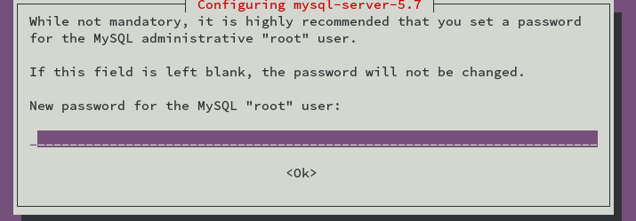

Enter a password for mysql root user.

Installing php 